Puspakom Things to modify:
1. Add a login screen
2. What does the number near the S1, S2, S3, S4 indicate? And why does S2 contain the title –“ Used EV with flood history - B5 + B7 for sale with bank loan”? I believe These sessions are nothing but a Lane sessions replay. 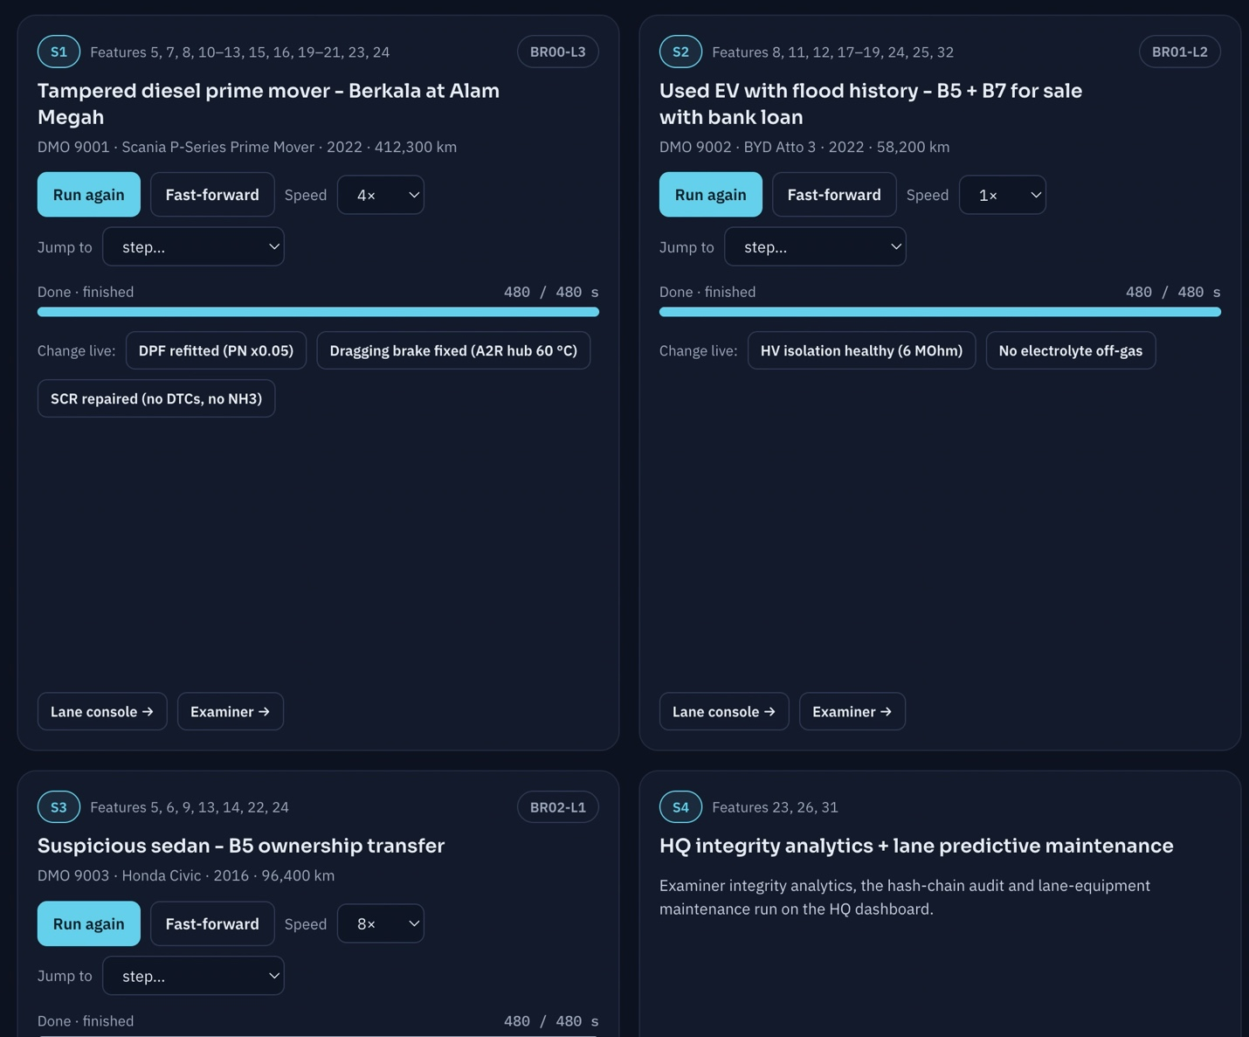

3. We do not need to show multi city lane options for a single logged-in user of a specific unit. This option can be moved to HQ operations. It can be car names with number plate as options.
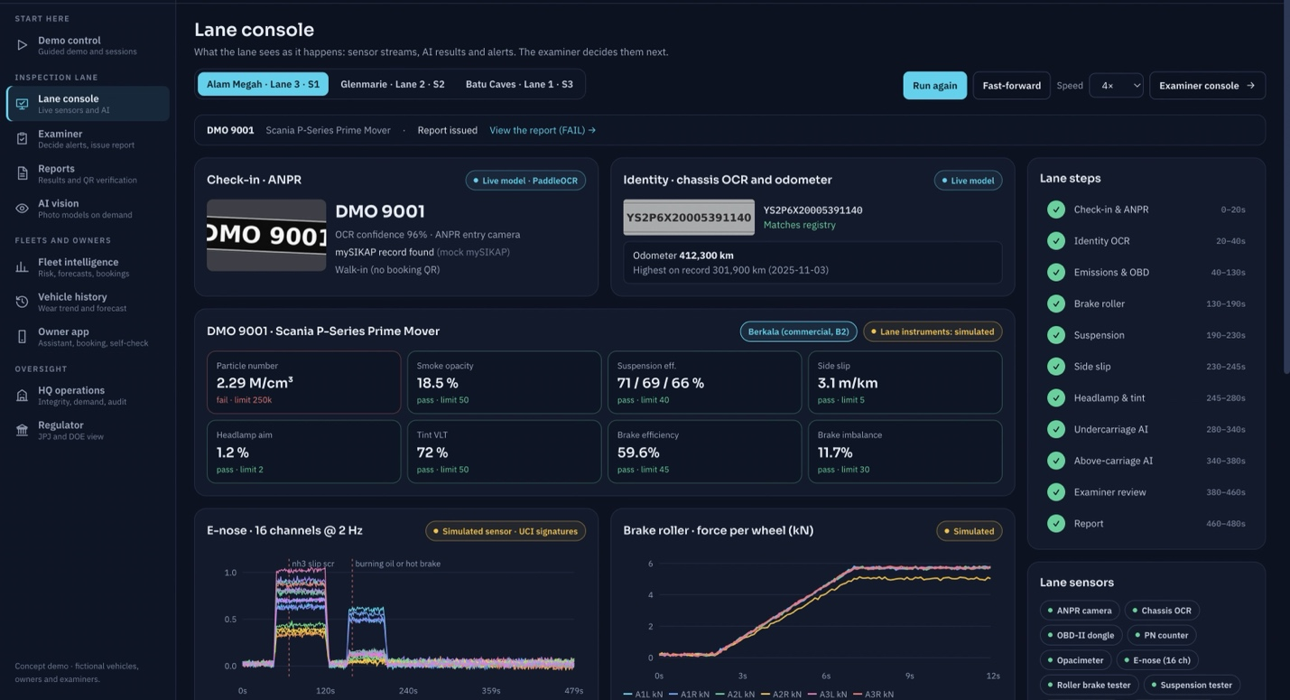

4. Why does the Vehicle which has 95 percent score has 45% chance of failing the next inspection? It doesn’t fit well here, even though it’s a synthetic data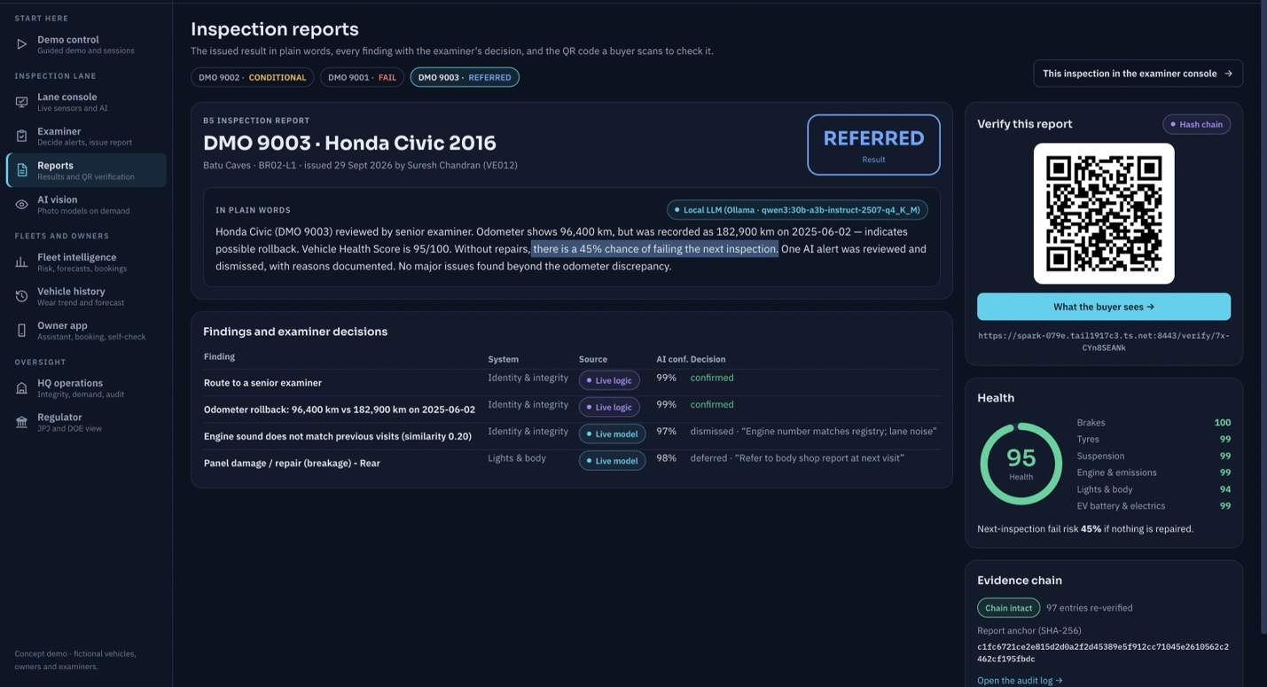

AI vision inspection:
Puspakom have implemented their own undercarriage vision system with the help of Keymag Sdn Bhd (), and also working on Project Astra: An above-carriage AI inspection system developed in collaboration with Universiti Tun Hussein Onn Malaysia (UTHM).AI Tyre Scans: Automated tread depth and wall damage detection systems to eliminate manual gauge checks.
Puspakom Steps Up Expansion and AI-Driven Inspections
https://www.motaauto.com/puspakom-showcases-malaysias-first-ai-assisted-inspection-technology/
https://newswav.com/article/puspakom-just-unveiled-an-ai-scanner-that-cuts-vehicle-inspection-times-fro-A2608_DdMvpS

Hence, project this screen in such a way that this is the output of their AI models and not our vision model analysis.
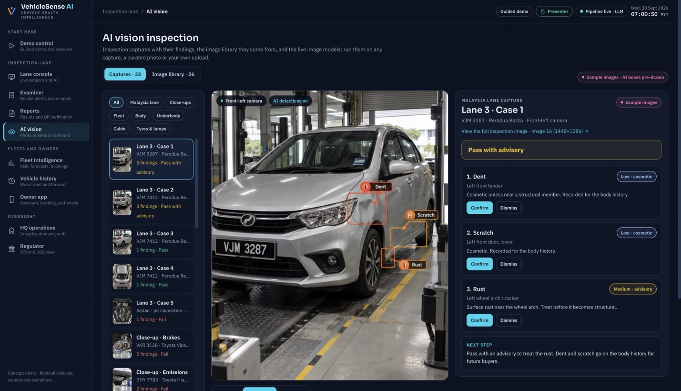

5. Remove this AI model detail in the owner app section. 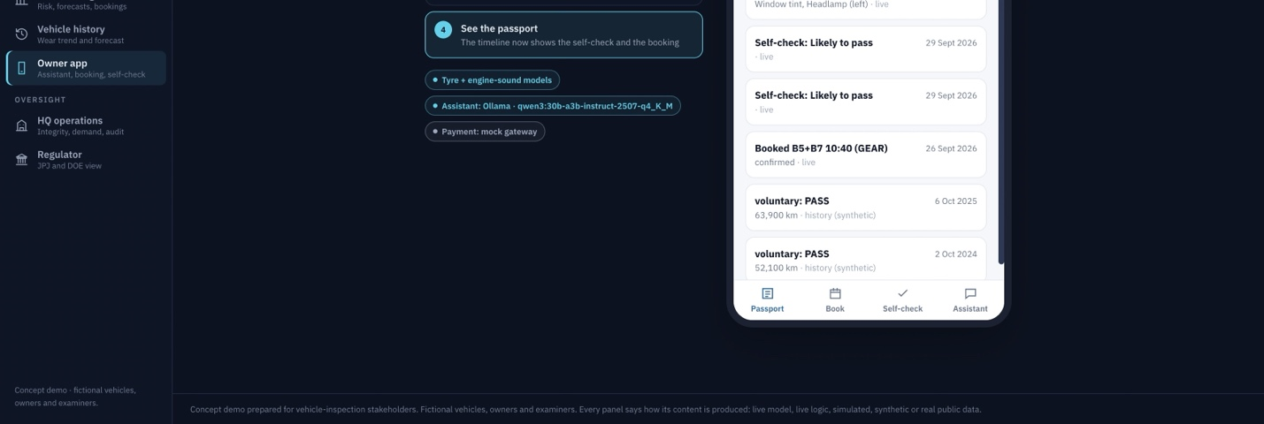
6. Show the e-nose option as a future R&D option and not an implemented current tech
7. Show lambda values for petrol cars along with CO/HC test results.

Possible new business opportunity:
6. Add a new option in Owner app “Sale”, which lists all the cars and bikes for sale. Since Puspakom has all the history of data from A-Z, this would help them and a possible trust in end user. When a user clicks on a car/motorbike then it shows its entire history + OBD details + images end to end.
7. Under oversight, Add a new tab for Sales, which shows all the vehichle for sale and its entire history or records with images, OBD details end to end.
Extra additions to existing features:
8. Use the govt JPS flood-station data, along with AI to analyze the cars on that particular area to identify flood damage or corrosion damage. These vehicles needs specific inspection
JPS flood-station data refers to real-time and historical hydrological information—such as water levels, rainfall, and river discharge—collected by Malaysia's Department of Irrigation and Drainage (Jabatan Pengairan dan Saliran, or JPS Malaysia).
9. If the current branch’s slots are full the owner’s app should recommend the nearby branches according to the location of the user with with available slots during the user chosen time in the same screen.
10. The owners app should show the history of all health certificate nt just the current item.

